LINUX COMMANDS
- pwd
- gedit
- cat
- mkdir

- cp
- cd
- rm
- rm -r
- rmdir
- find
- touch
- grep
- df -m
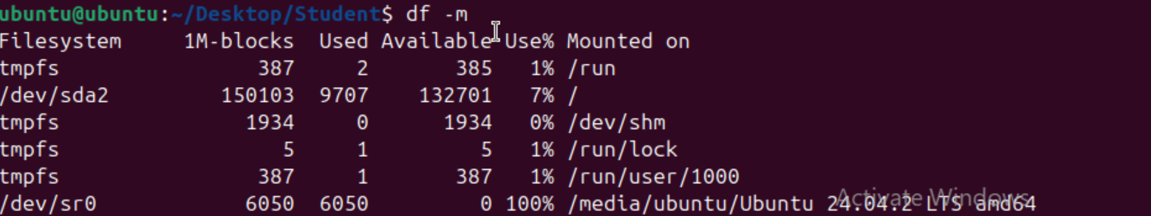

- sudo
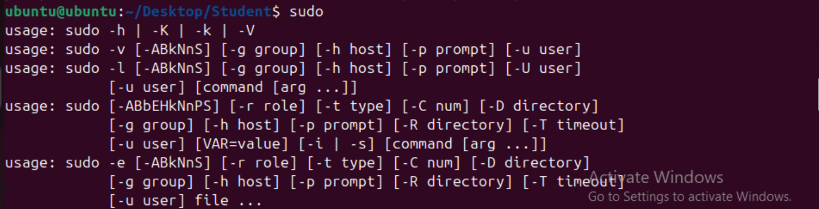
- sudo apt-get install
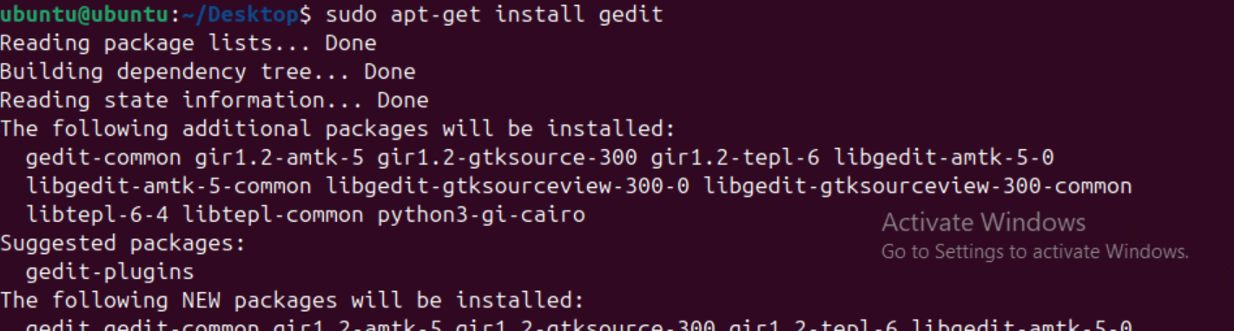
- chmod --help
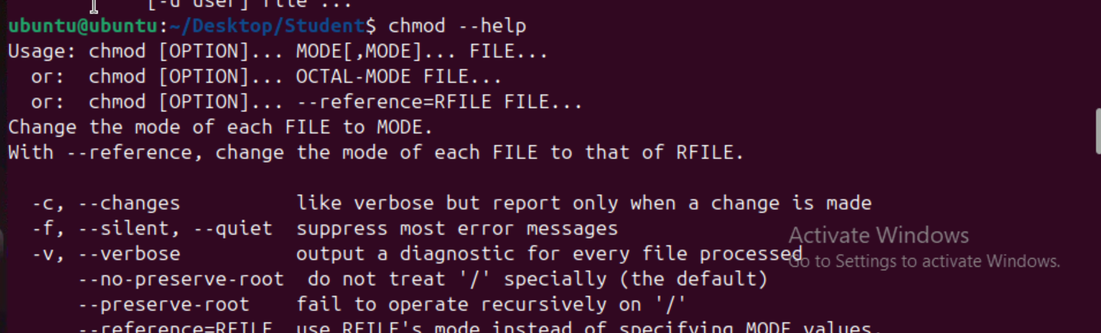

- wget
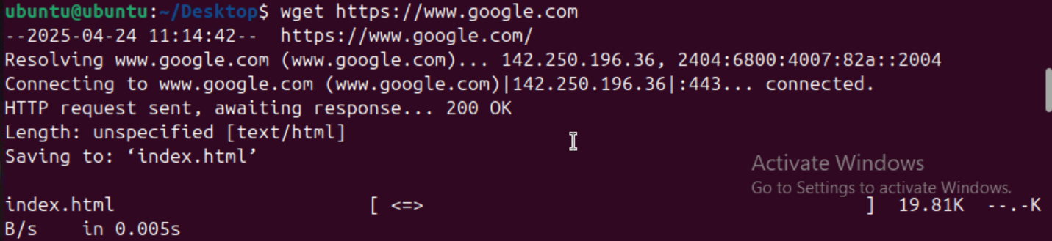
- tar

Trouble shooting
